1. 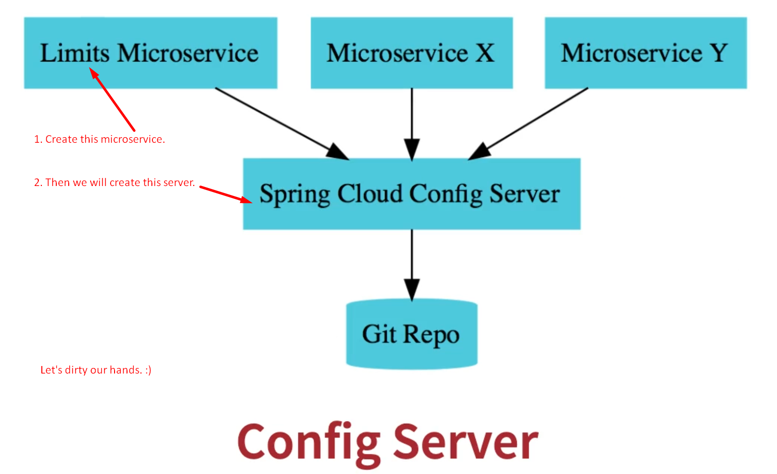
2. Let’s create Limit Microservice.
3. **Dependencies**:
   1. **Web**:
   2. **Devetools**
   3. **Actuator:** To monitor and manage your app.
   4. **Config Client:**
4. Now import:  
   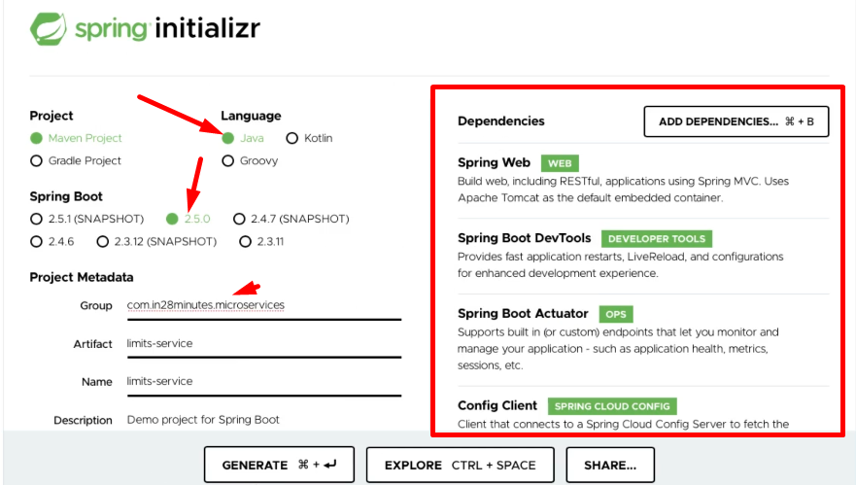
5. 